5.3 Independence of Path; Conservative Vector Field Worksheet

- Find , where and C is the curve from to .

Directly integrating along the curve C here will be very messy, so we consider taking another approaching. We can quickly see that if then and so F is conservative. Therefore, by the FTOLI we know that:

- Consider the vector field .
- Compute where C is the curve moving from to in .
We parameterize from to as for . Therefore,

- Construct two different paths that would connect the points and in .

One possible path would be along which we can parameterize as for .
Another possible path would be along which we can parameterize as for .

- Determine if F is independent of path.

There are many ways of determining this. We discuss several approaches below.
- We can check the value of where is some path connecting and other than the path used in part (a). If both paths produce different values then F cannot be independent of path.

Let be the curve parameterized by for (created in part (b)). We see that .
Since we know that F is not independent of path.
- We can check to see if for every closed path C in . If this is not true, then F cannot be independent of path.

Let be the curve parameterized by for which is a closed path in .
We see that
.
Since we know that F is not independent of path.

- We could check to see if F is conservative. If F is not conservative, then it cannot be independent of path.

We see that for some function h.
If this is true then it would have to be the case that but we already know that and this would mean that which is impossible!
Therefore, F has no possible potential function and is therefore not conservative.

- Determine if each of the following statements is TRUE or FALSE:
- The union of two simply connected domains is connected.
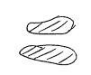
FALSE. We can easily see that if we take two simply connected regions as in the picture to the right, the total region is not connected.

- If a differentiable vector field F satisfies for every closed path C in an open, connected domain D, then there always exists a function f such that on D.

TRUE. If F is differentiable then it must be a continuous and therefore since for every closed path C in D it must be true that is independent of path in D and thus it must be conservative which means there exists a function f such that on D.

- If a differentiable vector field satisfies on a connected domain D, then F is conservative on D.

FALSE. We would also have to guarantee that D is simply-connected in order to reach this conclusion.

- If for some closed path C, then F must be a conservative vector field.

FALSE. It must be the case that for every closed path in order to say that F must be conservative.

- Consider the vector field.
- Find a function f on whose gradient is F.

We see that for some function h.
If this is true then it would have to be the case that but we already know that and so which implies that for some function g.
So, thus far, we have that .
If this is true then it would have to be the case that but we already know that and so which implies that for some constant C.

Therefore, we conclude that

- Compute the line integral , where C is a line segment from to .
Since, from part (a), we know that F is conservative we will apply the FTOLI and find that

Note: We could also calculate this directly but it would be a bit messier.

- Let . Determine whether F is a conservative vector field. If it is, find its potential function.

We see that for some function h.
If this is true then it would have to be the case that but we already know that and this would mean that which is impossible!
Therefore, F has no possible potential function and is therefore not conservative.

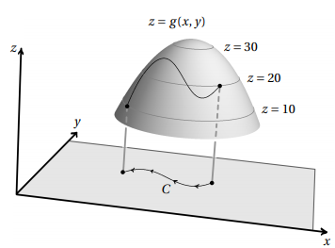
- Let be the function whose graph is shown at the right, and let C be the indicated curve in the xy-plane. Using only this information evaluate the line integral .

We can see that the indicated curve begins at the point when and ends at the point when .

Since clearly the vector field is conservative (its potential function is g) then we can apply the FTOLI and calculate that

- Consider the vector field on .
- Show that F is conservative by finding its potential function .

We can clearly see that for some function g.
Then we can say that , but since we already know that it must be that for some constant C.
Therefore, and thus F is conservative.

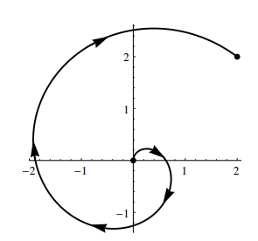
- For the curve C shown at the right, evaluate .

Since F is conservative and C begins at the point and ends at the point , then by the FTOLI we know that

- Consider the curve C which is a straight-line segment from to .
- For , compute .

We can parameterize C as for .

Therefore,

- For , compute .

Clearly is a conservative vector field and therefore by the FTOLI

- Circle the best estimate for .
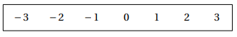
Along C, the function is very close to 1. Therefore,

- Let be the vector field defined by .
- Let C be the unit circle oriented counterclockwise. Show that . (You will need to split the integral into two pieces).
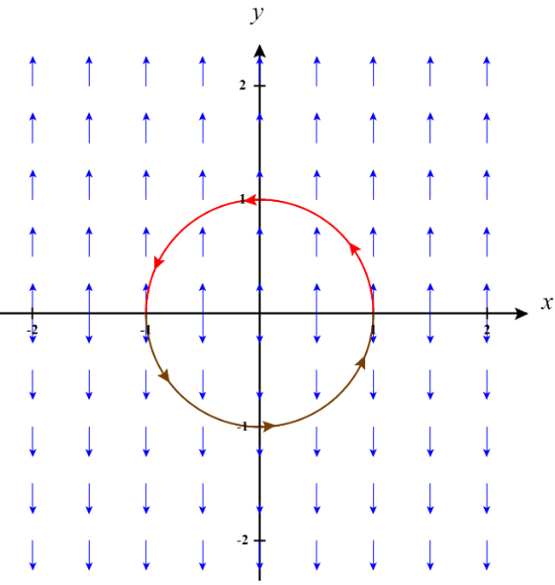

We parameterize C into two separate paths representing the top and bottom of the unit circle. where and where .

We then calculate that

b) It turns out that is true for any closed curve C in the plane and not just the unit circle. But, this vector field is not conservative. Explain why this vector field cannot be conservative.

If this vector field is not conservative, then this must mean that we cannot find a potential function for it. We can see that this is true since when we would need where is a constant.
When we would need where is a constant. In order for both of these to be true at the same time we would need (so that y is always made positive and our constants match).
However, we know that must be differentiable at but this would not be true.
Therefore, there is no function f so that .

- Let D be the set of all point in except for . In each part below, indicate whether a continuous vector field with domain D and the property described is necessarily conservative or not necessarily conservative. (If the vector field is never conservative, circle not necessarily conservative.)

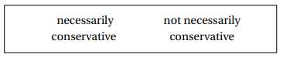
- .

is

We can clearly see that for some function g.
Then we can say that , but since we already know that it must be that which is impossible. Therefore is not conservative.

- has the path independence property; that is, the line integral is independent in D.

is

Since is continuous and defined on (except at ) which is open and connected, and is independent of path then it must be the case that is conservative.

- where over D.


is

Since is defined on except at then it is not simply connected and therefore we cannot use the theorem from section 5.3 regarding be conservative. We cannot say for certain whether will be conservative or not.

- has the property that for the unit circle (given by ), .

is

We need to be sure that for every closed curve C, in order to guarantee that is conservative. Therefore, is not necessarily conservative.
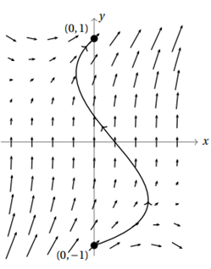
- A continuous vector field F, defined on , is shown at the right. For the sake of understanding the scale in this picture let . Assuming that F is conservative, circle the value of , where C is the curve shown from to .
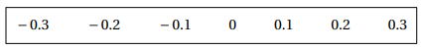

F is conservative and since we are working in , which is open and connected it must be independent of path. Therefore, the value of , where is the path in blue which progresses up the y-axis. We can parameterize as where . We see that the vector field F is basically constant on the y-axis and therefore we can say that along our path .

Therefore,

